**User Documentation**

1. **Installation Guide**

You only need to get JRE installed in your PC as this application is developed using java language, so JRE is necessary to execute this project.

Moreover, in this application, user’s data is saved in different format files in a directory named as ‘profiles’. There can be multiple files such as one text file will contain user’s profile information, another text file will contain posts made by users, and last text file will contain user’s friends. These files will be saved as user.txt, posts.txt and friends.txt respectively. Images posted by user will be saved in a format in which they are. So, for saving this data, you should have enough space.

1. **User Manual**

This social media application offers several features for getting best user experience while connecting with others on internet across the globe.

1. After launching application, you would be landed on a login / sign up page.

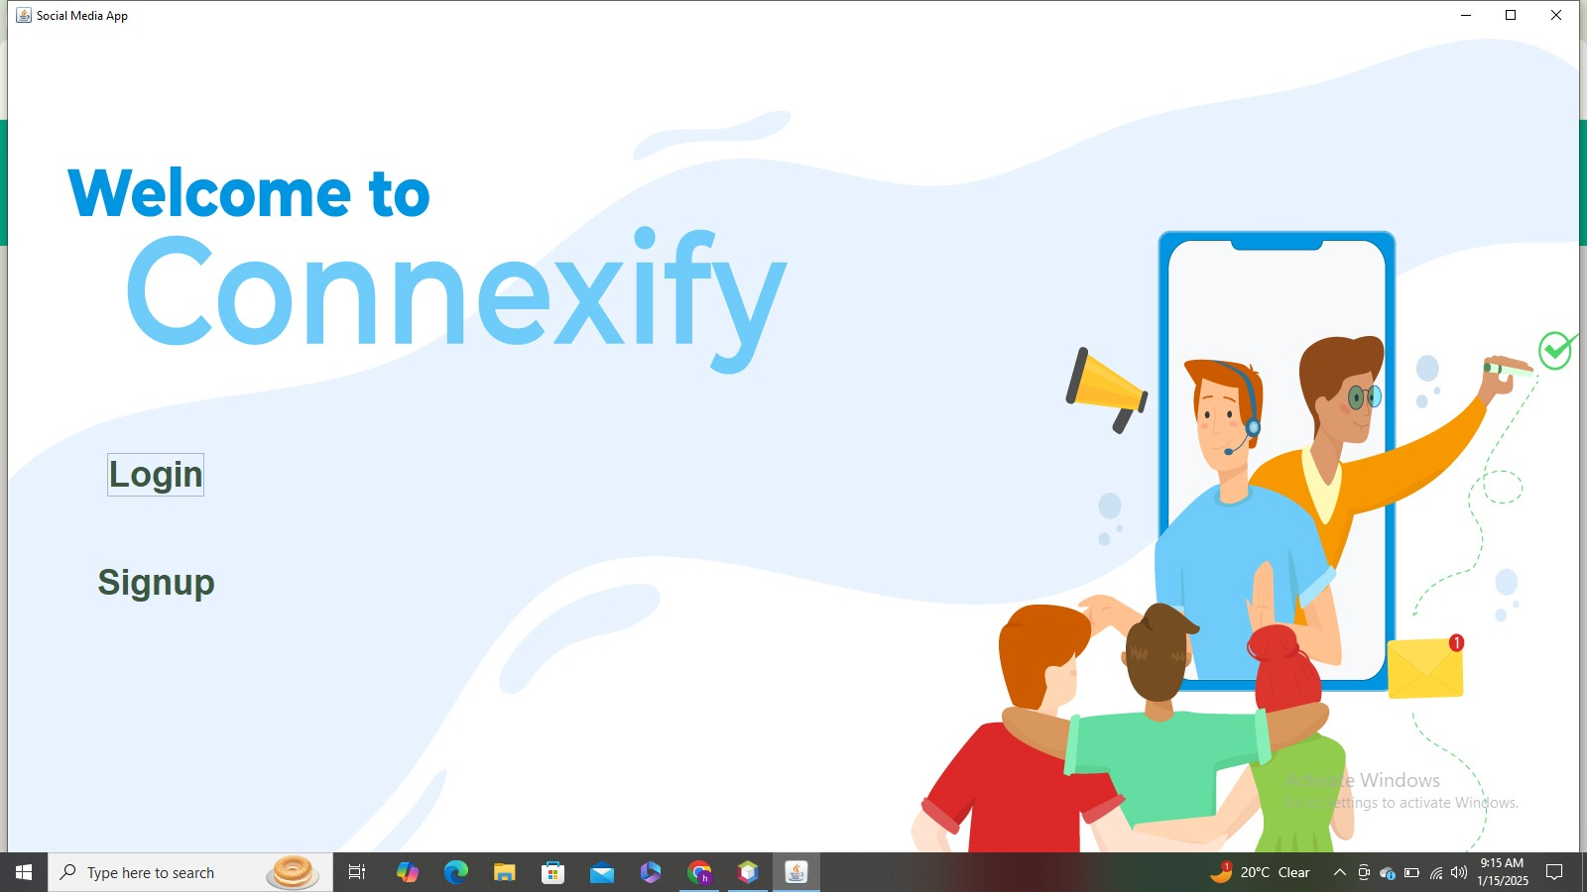

1. As a new user, you need to sign up the account by providing valid information like your name, password, email ID, gender and profile picture.

**Note:** User password should be alphanumeric, 8 characters long but maximum 16 character and include at least one special character and uppercase letter.

* Additionally, email should be provided in appropriate format as “sk[23k[9”+@gmail.com

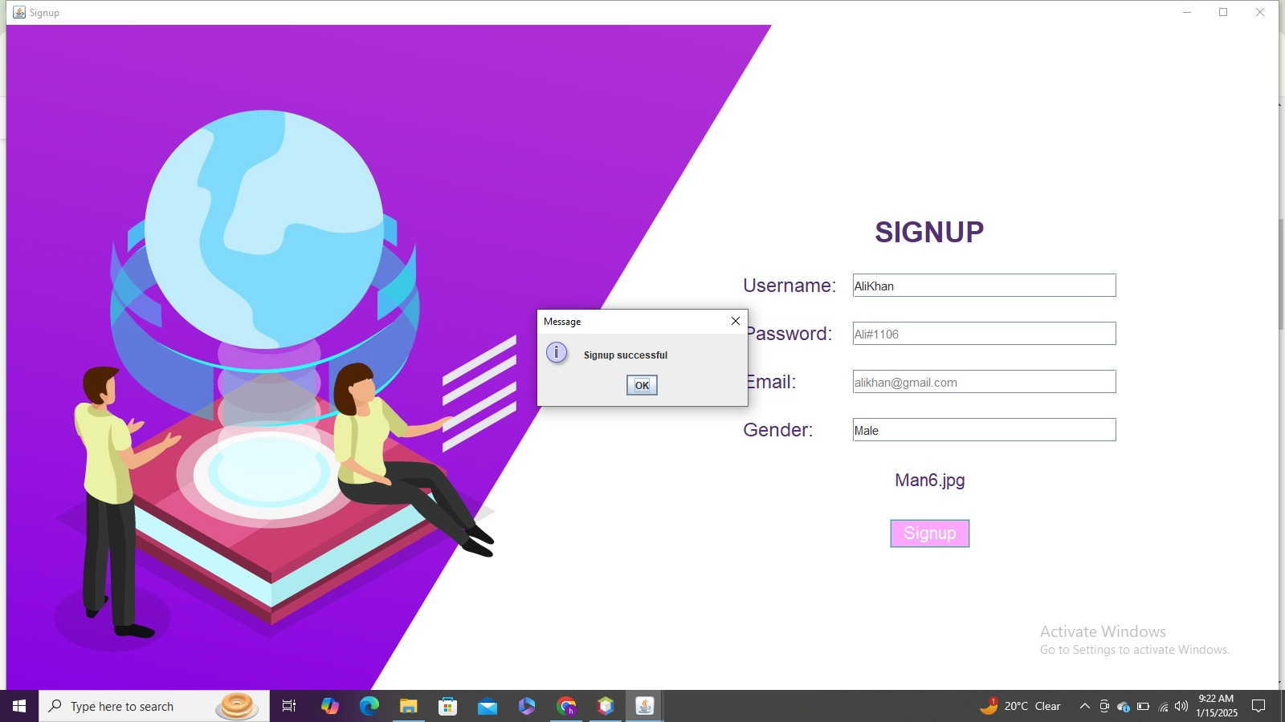

After successful sign up, you would be shown message “sign up successful” that means your account is created.

1. Now you would have to login after creating account successfully.

* After successful login, you would be landed on feed page where there would be currently no posts because you would have not added any friends yet.

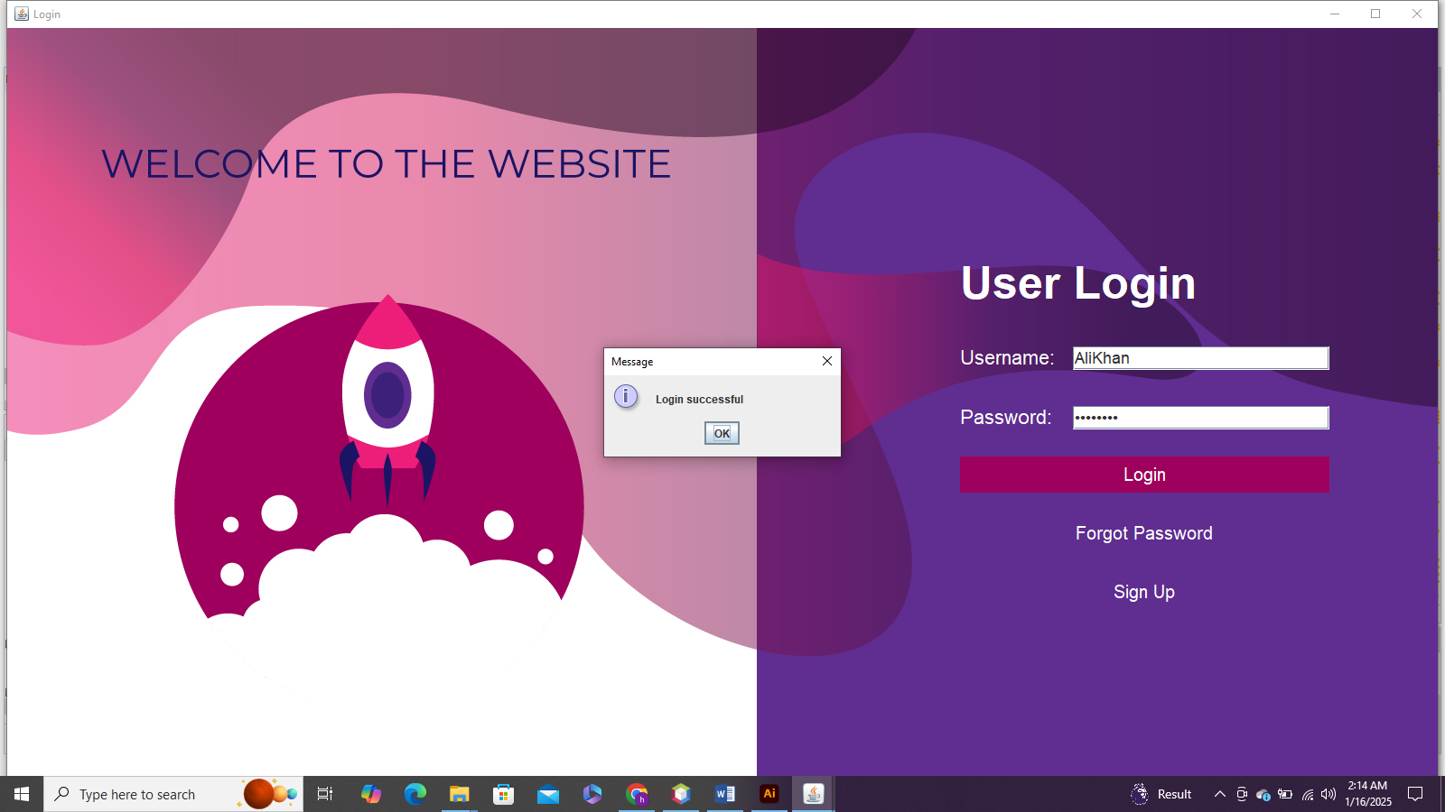

* In case you forgot your password so you can click on forgot Password to retrieve your Password by system.

Here you have to write your correct email to retrieve your Password

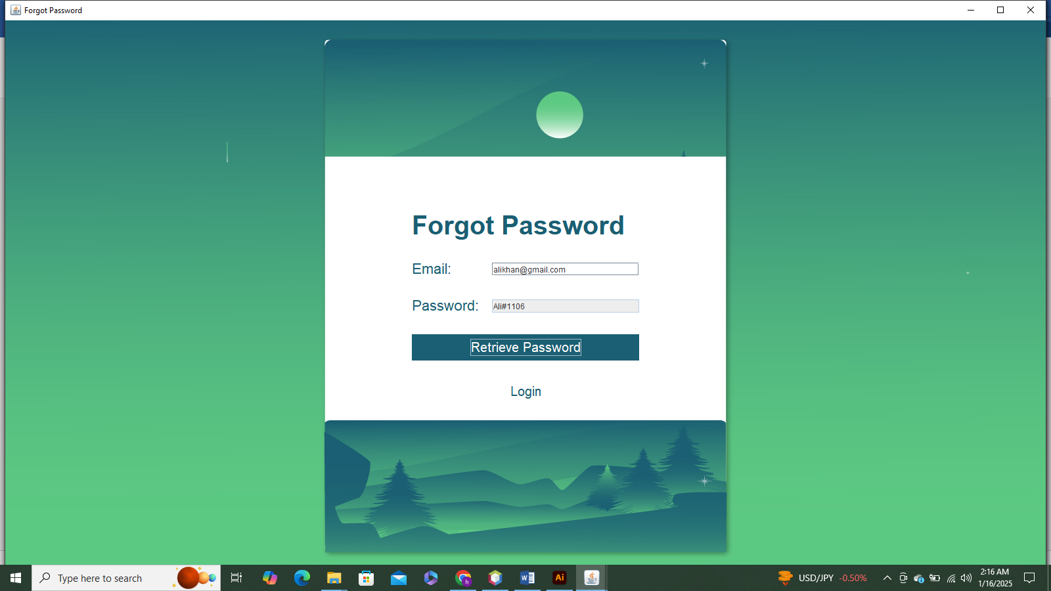

1. After a successful login you will be able to see the homepage/landing page

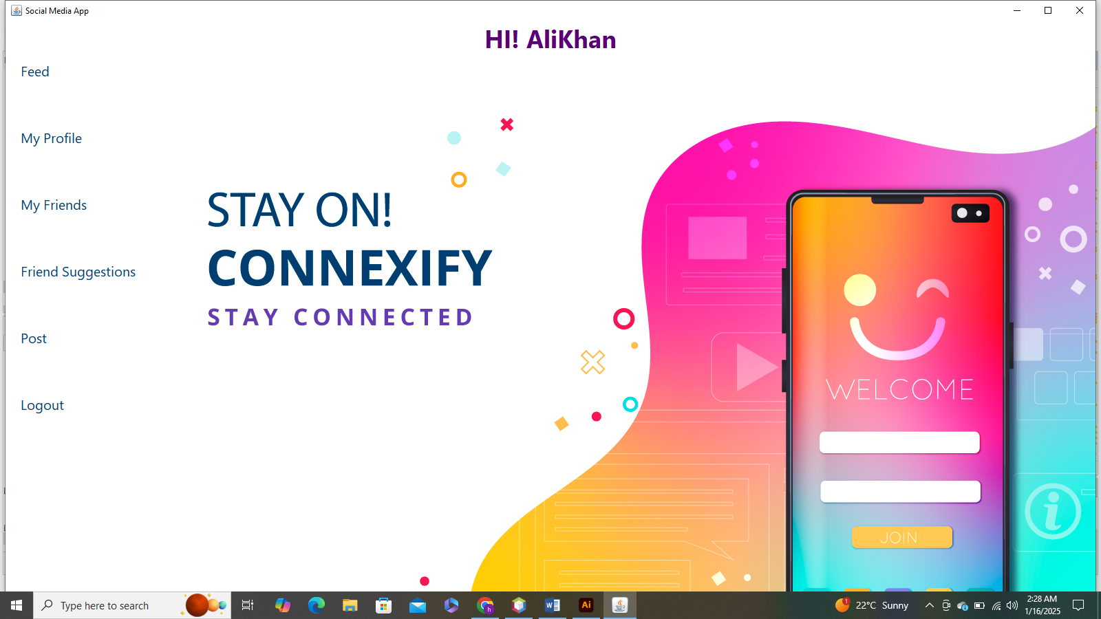

*Here, you can see a menu which includes suggested friends, post, your friends, your profile and logout option.*

1. In the beginning since you haven’t post any thing so there will be no posts there at all.

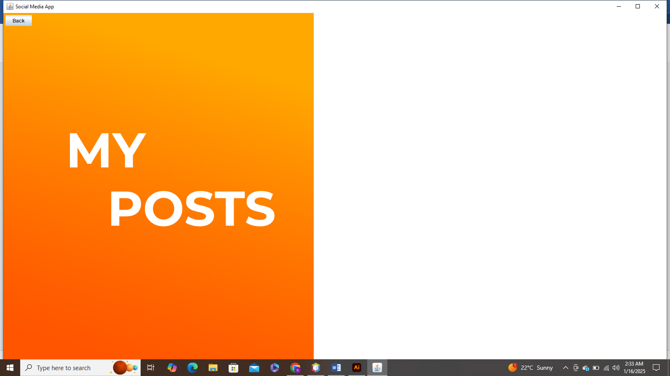

* So, you can post by clicking in post button in main menu and add some posts there after adding some posts so you can your posts in this section.

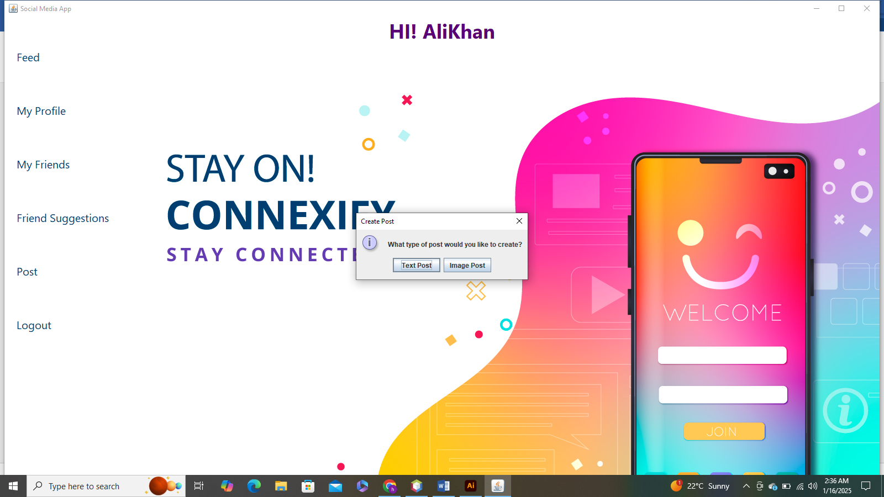

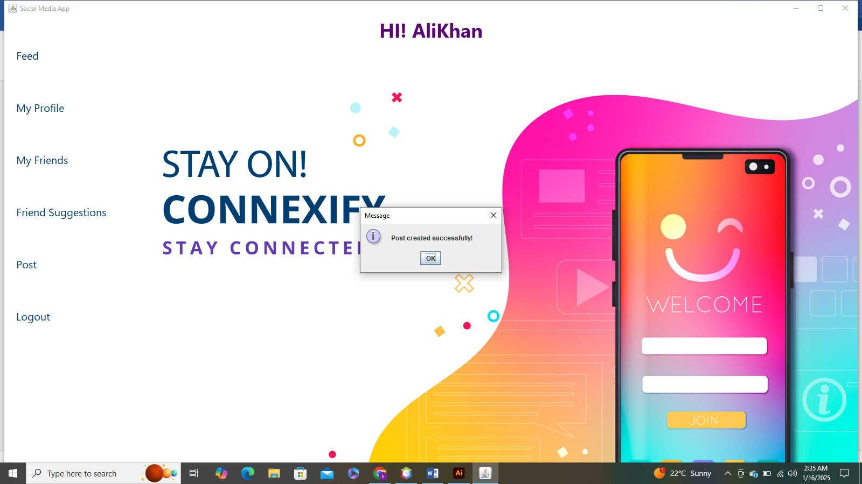

* Feed section After posting

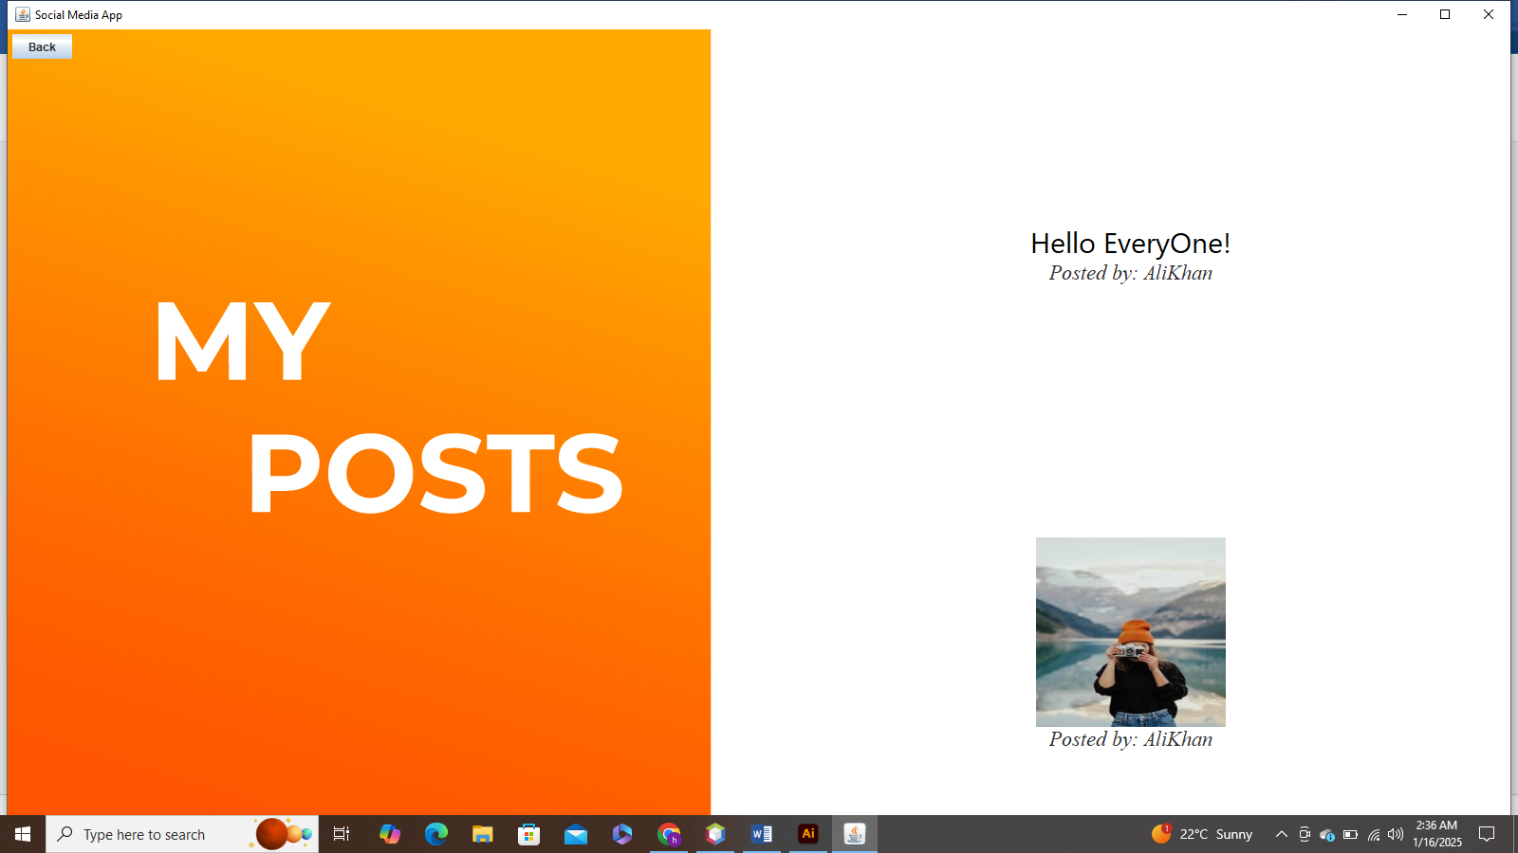

1. In ‘my friend’ feature, there would be obviously showing no friends in the list because you are new and have no friends. Ultimately, at this point you need to add friends first from suggested friend list then you would be able to see your friends’ posts in feed.

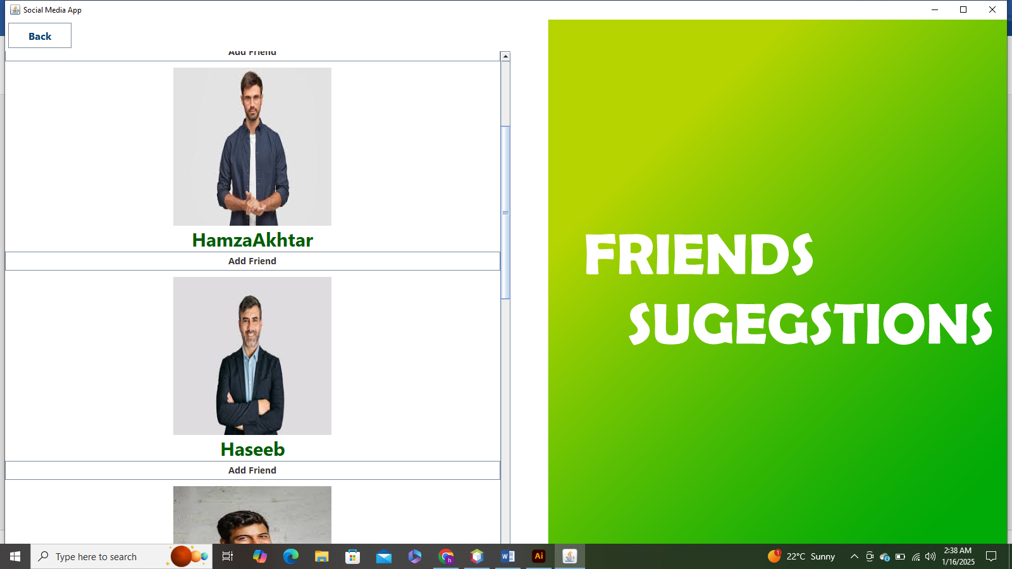

* You can add friends by clicking on Add Friends Button.

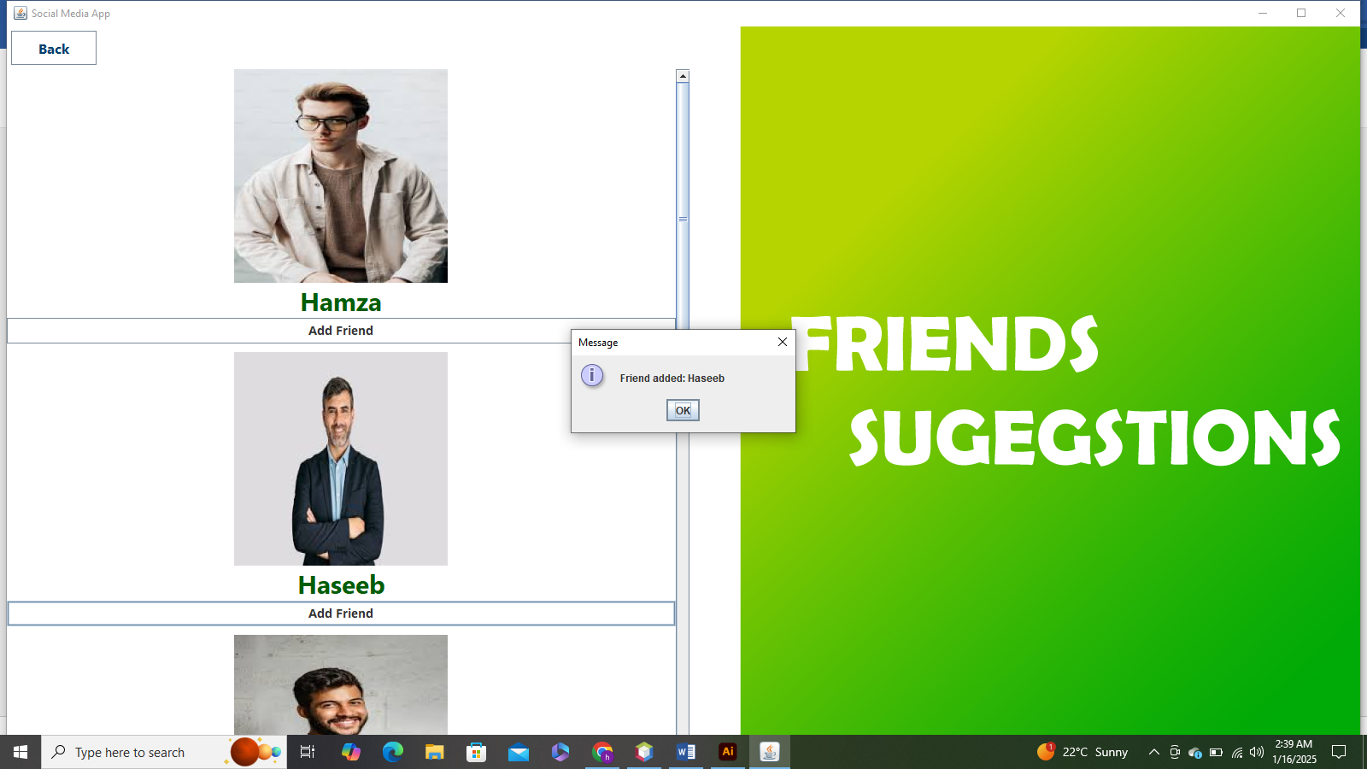

1. Now You can see Your friends in My Friends Section

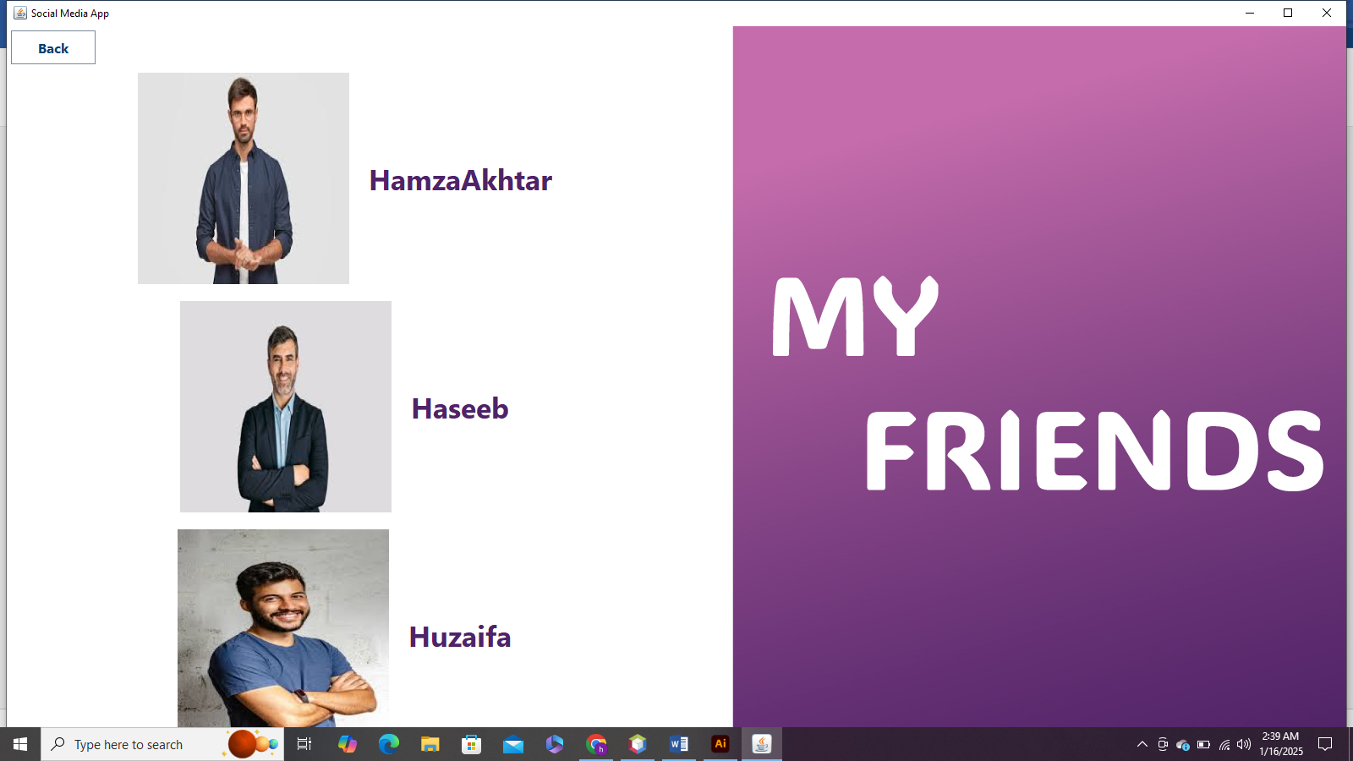

1. Moreover, if you want to see your profile, go to profile section where our profile info and your done posts will be visible.

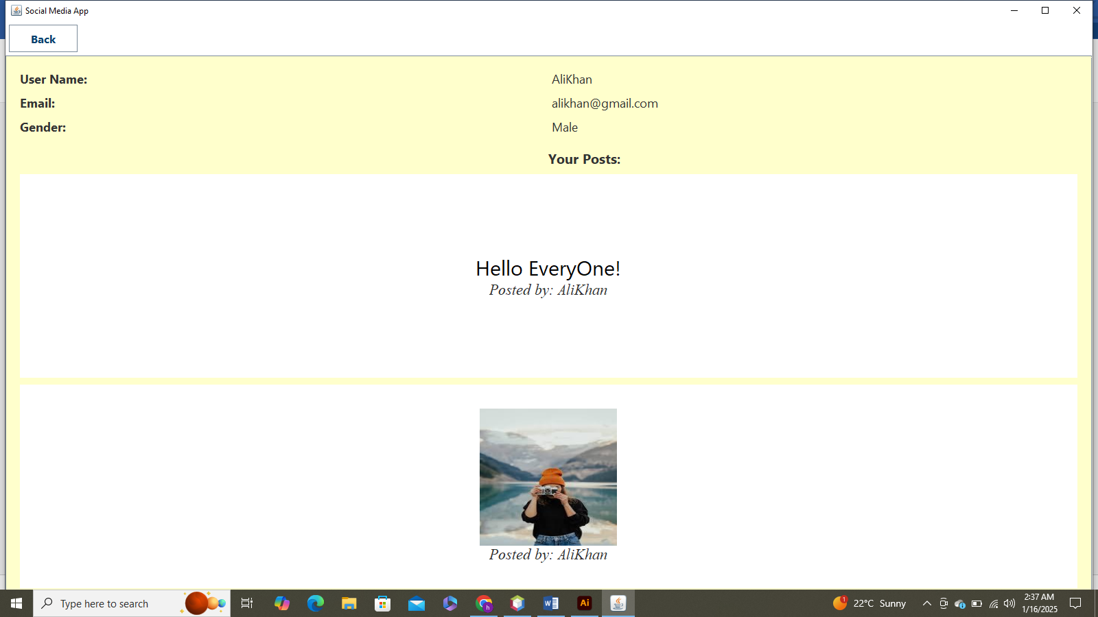

*Finally, after having a good time on internet while enjoying with your social media friends, you can logout your account for enhanced security.*

1. Moreover, You can see your friend’s post as well in Feed section to get updated about your friends.

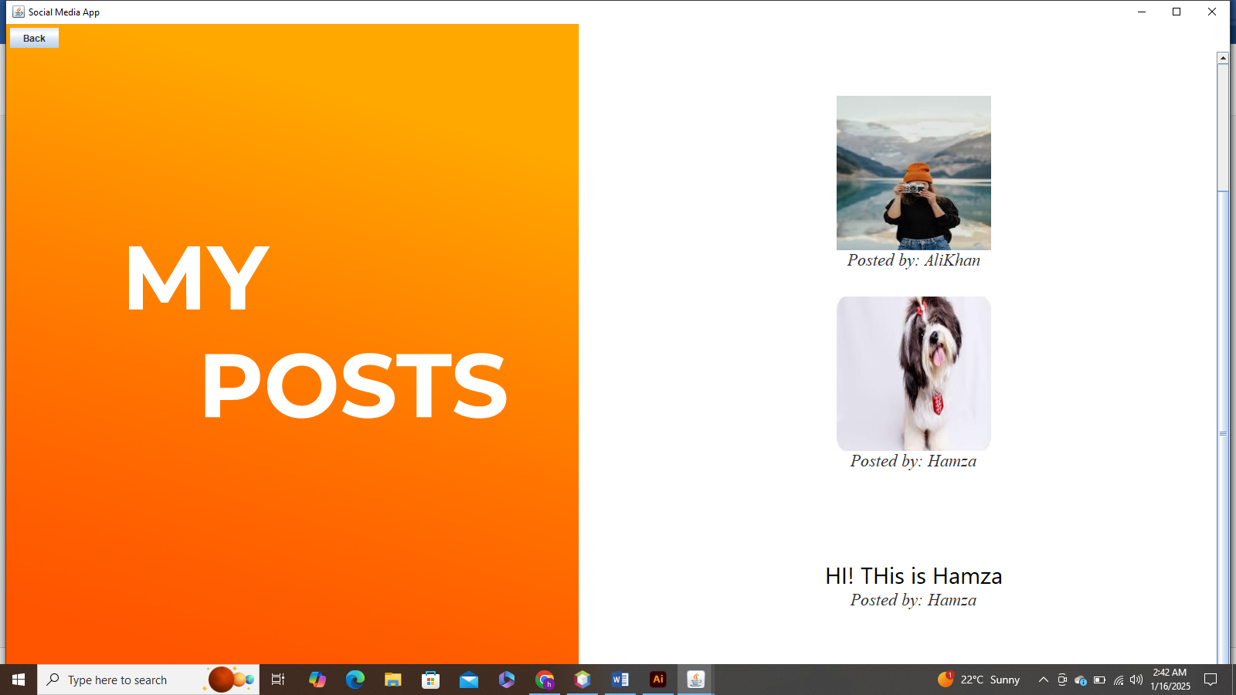

*Hopefully, you would enjoy your social network by watching your friends’ posts and posting your own content.*